*Florida International University*

*School of Computing and Information Sciences*

CIS 4911 Senior Capstone Project

Test Case Management System

**USER GUIDE**

**Group Members**

Artiom Tiurin

**Mentors**Tariq King  
Dionny Santiago

Justin Phillips

**Instructors**Masoud Sadjadi  
Juan Caraballo

**INTRODUCTION**

The Test Management Project functions based on the needs and specifications of the Solution Testing Team at Ultimate Software. The present guide includes the step by step general tasks involved with the creation, edit, update, deletion of test cases as well as the mechanism involved for retrieving test Automation metrics and persistent interchangeable storage of the information required for interoperability TSF,MTM, and expandability for other systems. The system is responsible for synchronizing its own model with 3rd party management systems such as Phoenix and maintaining overall integrity of the data wherein. The system includes metrics for test case failure rates, failure types, and tie these metrics into suites and code files. These metrics should be displayed in a graphical, easy to read format. A mock automation aspect of the system was pursued by the extent permissible of resources for this project.

**HARDWARE AND SOFTWARE REQUIREMENTS**

# **GETTING STARTED**

The test Case and Automation Management System on main test plan view. Initially as the web application is launched credentials will be requested in order to enter the test plan and automation main screen for viewing and manipulating according to permissions. The following are the main views of the test plan screen explained in order of occurrence:

## **Security Credentials:**

Windows Single Sign On was designed for the Test Case & Automation Management System. As soon as the web application is launched a credentials popup will be prompted in order to verify permission to access the test plan.

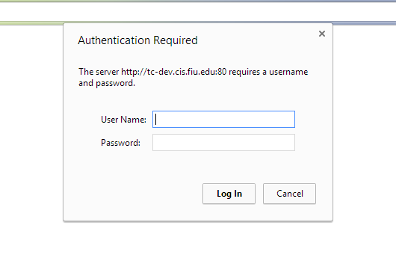

## **Project Selection:**

After credentials have been correctly submitted (your local System’s username and password or Team Foundation Server’s credentials (user:TFS, pswd:*******)), a screen asking for a project selection will appear. Select an existing project from the dropdown circled in red shown on the screenshot.

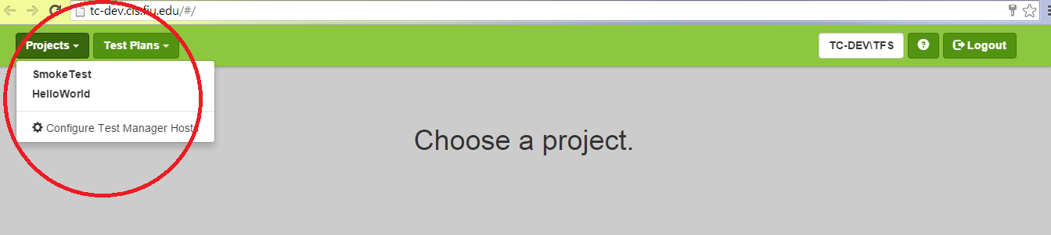

## **Test Plan Request:**

Wait while the application requests the existing selected project and retrieves its test plans from the server, during the process the following screen will display

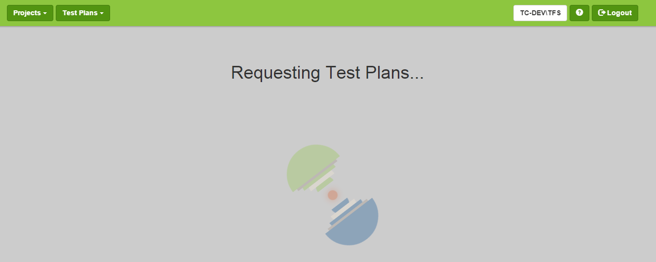

## **Choose Test Plan:**

The test plans have loaded and are now available. Select an existing test plan from the dropdown as shown on the screenshot  
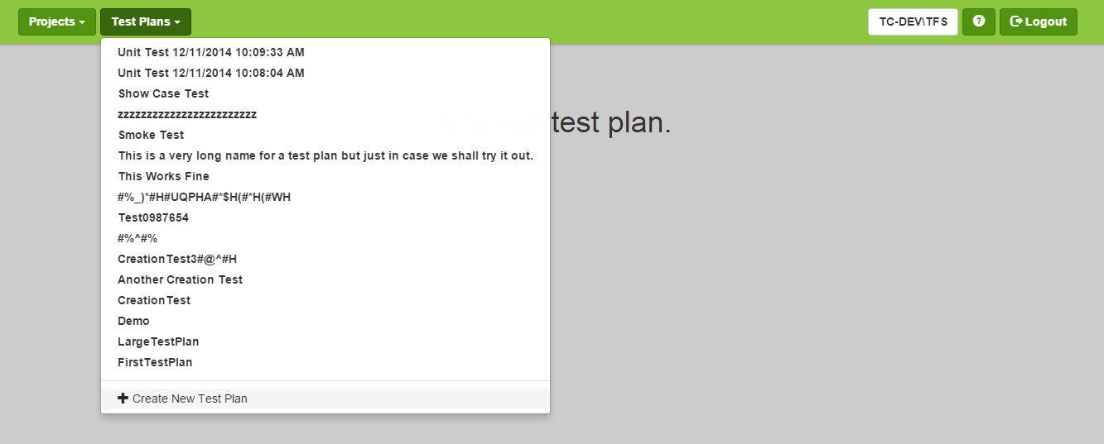

## **Main View:**

Test plan selected is now displaying on screen for manipulation of test suites, cases and steps as well as viewing of details.

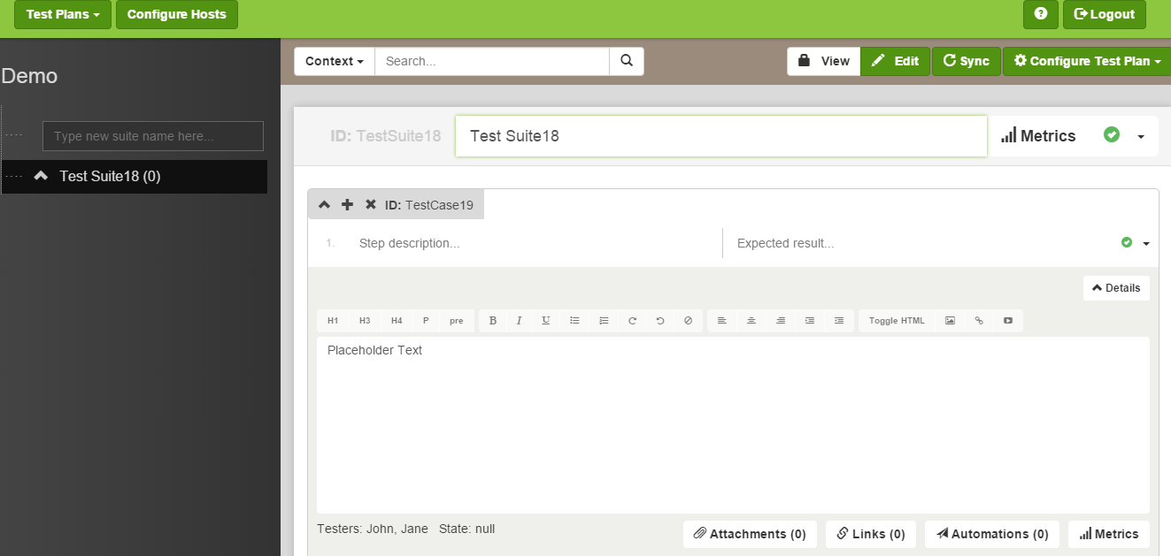

* **How to Create a Test Suite?**

**Preconditions**

1. Tester is logged in the test manager
2. Actor has accessed the Test Case page

**Description**

1. The use case begins when the tester clicks on the plus sign from the suites left panel. (Trigger)
2. The user then inputs a Suite Case title.
3. The use case ends when the tester hits enter to add the suite with the provided information

**Post-Conditions**

1. The Actor gets access to the new suite on the hierarchical menu list.
2. The Actor may now add test cases to this suite.



* **How to create a Test Case?**

**Preconditions**

1. Tester is logged in the test manager
2. Actor has accessed the Test Case page
3. Actor has chosen the Test Suite where he wants to create a new test case

**Description**

1. The use case begins when the tester clicks on add sign beside a Test Suite on the main panel to add a test case to this suite. (Trigger)
2. The system responds by loading an editable tab to name a test case.
3. The tester fills the tab with a test case title
4. The use case ends when the tester hits enter to add the case with the provided information

**Post-Conditions**

1. The new test case will be added on the hierarchical menu list under its correspondent test suite.
2. The Actor may now access and edit this test case.



**How to create a test step?**

**Preconditions**

1. Tester is logged in the test manager

2. Tester has created a test case

3. Tester has chosen the test case to be added steps

**Description**

1. The use case begins when the tester clicks on pull down test case

2. The system responds by loading the corresponding test case’s steps document

3. The user clicks on the plus sign button and types new step

4. The use case ends when the tester hits enter and changes have been saved on the test case

**Post-Conditions**

1. All actors are able to see the newly modified steps

2. A previous version of the test case steps has been backed up

## **Details Section View:**

## **NOTE:** in order to use **Metrics, RunAutomation** and **BNA** buttons, user/developer must first launch a mockPhoenix server:

## -navigate to your project folder: ..Test-Flow-Ver-2.0\Code\MockPhoenix

-start/Run as Administrator .exe file: MockPhoenix.exe

-use API Documentation: Mock Phoenix Server Documentation.txt found in the same location.

The details section presents data about a particular use case, including linked files, test metric results, attachments and BNA results!

METRICS:

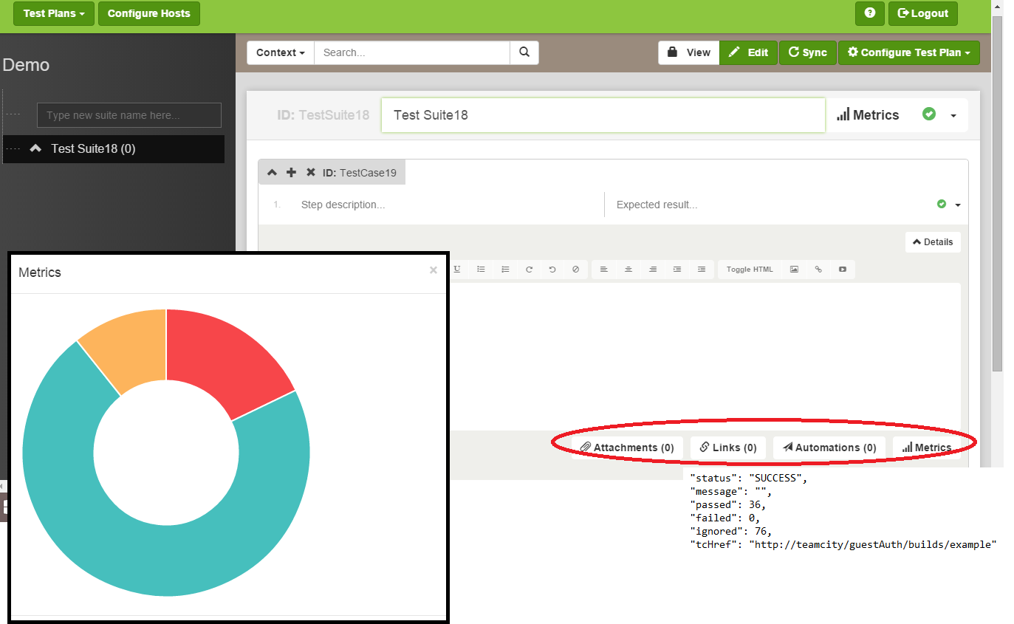

BNA:

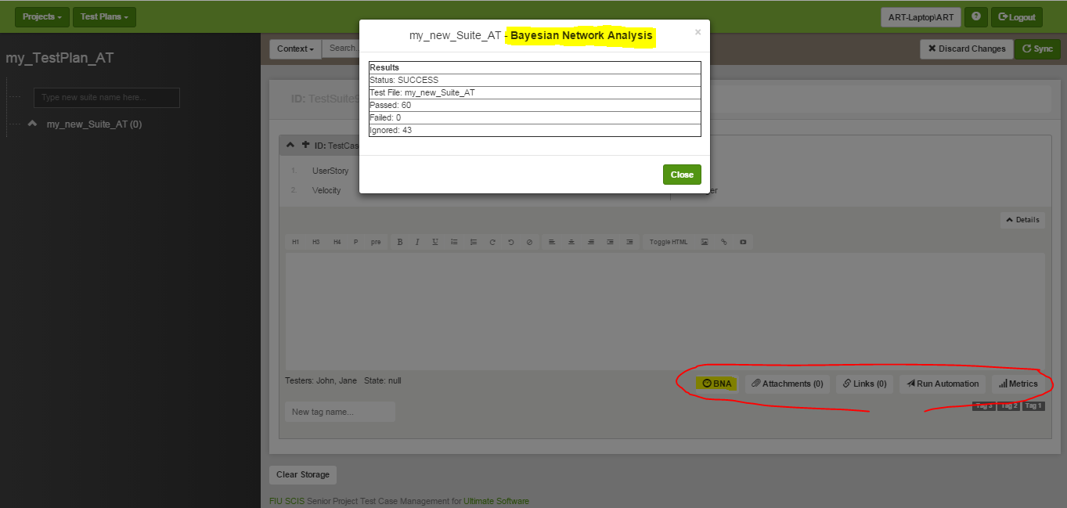

# **USE CASE SAMPLE SCENARIOS TO TRY:**

**Scenario 1:** Tester Runs a Test Suite & Checks Analysis Report

1. Tester Logs In the test case manager
2. Tester opens a test suite already created with test cases
3. The tester runs the test suite’s test cases
4. When the test suite is done running, the tester clicks on Generate Analysis
5. Tester specifies the time range of the analysis for the past 2 weeks
6. A chart with pass and fail percentages is generated using all the current test suite’ result data from the last 2 weeks.

**Scenario 2:** Tester Associates a Code Repository to a Test Case

1. Tester Logs In the test case manager
2. Tester Selects an existing test suite
3. Tester Selects and existing test case inside the current test suite
4. Tester clicks on “Associate Repository” once inside the test case
5. A popup window appears with all the code repositories available
6. Tester selects the project and file desired to associate to case
7. Once a file has been selected, the tester clicks OK.

**Scenario 3:** Tester Adds an Attachment to Test Case

1. Tester Logs In the test case manager
2. Tester Selects an existing test suite
3. Tester Selects and existing test case inside the current test suite
4. Tester clicks on “Attach a File” once inside the test case
5. A popup window appears to select existing files on the computer
6. Tester selects a scheen-shot from the Desktop
7. The tester then clicks “Save” and the scheenshot is uploaded and available on the attachments column of the test case

**Scenario 4:** Tester Adds Existing Steps to a Test Case

1. Tester logs in to the test case manager
2. Tester creates a test case
3. The tester selects an existing test suite from the left tab
4. The tester checks the “search steps” box below the search option of the test suite
5. Tester types keywords found on a particular test step on te search tab and clicks on search
6. The tester then drags test steps returned from the search results and drops them on the current test case’s steps column.

**Scenario 5:** User pushes a test plan to remote management systems

1. User logs in to the test case manager
2. User clicks on Test Suite
3. User modifies the test suite, test cases, test steps
4. User presses sync button to push test plan to remote repositories.